**DAILY ONLINE ACTIVITIES SUMMARY**

|  |  |  |  |  |  |  |  |  |  |  |
| --- | --- | --- | --- | --- | --- | --- | --- | --- | --- | --- |
| **Date:** |  | **06-06-2020** | | | |  |  | **Name:** | **Suhas prasad shetty** | |
|  |  |  |  | |  |  |  |  |  |  |
| **Sem & Sec** |  | **8th sem B** | | | |  |  | **USN:** | **4AL16CS080** | |
|  |  |  |  |  |  |  |  |  |  |  |
|  |  |  |  |  |  | **Online Test** | | **Summary** |  |  |
|  | |  |  |  |  |  |  |  |  |  |
| **Subject** | |  | **IOT** |  |  |  |  |  |  |  |
|  | |  |  |  |  |  |  | |  |  |
| **Max. Marks** | |  | **30** |  |  |  | **Score** | | **29** |  |
|  |  |  |  |  |  | |  | |  |  |
|  |  |  |  |  | **Certification Course Summary** | | | | | |
|  | |  | | |  |  |  |  |  |  |
| **Course** |  | **Amazon DynamoDB for serverless architectures** | | | |  |  |  |  |  |
|  |  | | |  |  |  |  | |  |  |
| **Certificate Provider** | | | |  | **AWS** |  | **Duration** | |  | **2hrs** |
|  |  |  |  |  |  |  |  | |  |  |
|  |  |  |  |  |  | **Coding Challenges** | | |  |  |
|  | | | |  | | |  | | | |
| **Problem Statement-** : | | | | **1)** Python program for **given a two list. Create a third list by picking an** | | | | | | |
| **odd-index element from the first list and even index elements from second.** | | | | | | | | | | |
|  | | | |  |  |  |  |  |  |  |
| **Status: completed** | | | |  |  |  |  |  |  |  |
|  | | | | | |  |  | |  |  |
| **Uploaded the report in Github** | | | | | |  | **yes** | |  |  |
|  | | | | | |  |  | |  |  |
| **If yes Repository name** | | | | | |  | **Suhas** | |  |  |
|  | | | | | |  |  | |  |  |
| **Uploaded the report in slack** | | | | | |  | **yes** | |  |  |
|  |  |  |  |  |  |  |  |  |  |  |

**Online Test Details**



**Certification Course Details**

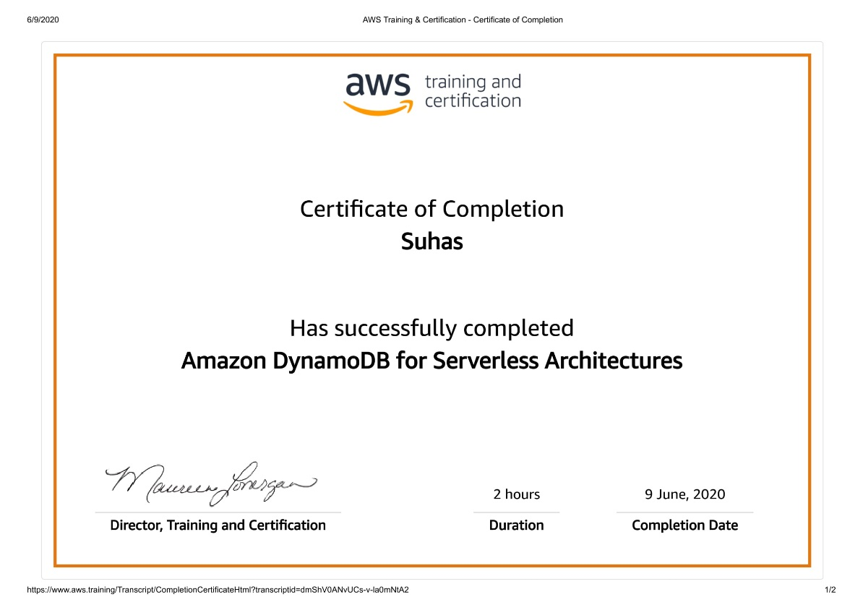

**Coding Challenges Details**



listOne = [3, 6, 9, 12, 15, 18, 21] listTwo = [4, 8, 12, 16, 20, 24, 28] listThree = list()

oddElements = listOne[1::2]

print("Element at odd-index positions from list one")

print(oddElements)

EvenElement = listTwo[0::2]

print("Element at even-index positions from list two")

print(EvenElement)

print("Printing Final third list")

listThree.extend(oddElements)

listThree.extend(EvenElement)

print(listThree)